Media Pack:
The Finding Place
by Julie Hartley
a novel for ages 9-13

The Finding Place: A Synopsis
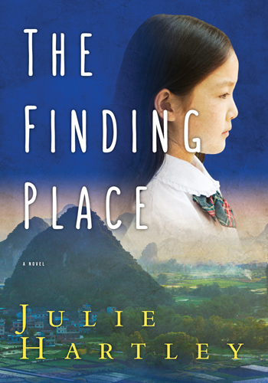
Found as a baby outside a school in China, Kelly Stroud is adopted and raised by North American parents. One day, her dad leaves the house to buy milk, and doesn't come back. Struggling anew with what it means to be loved and then left behind, Kelly embarks with her mother on a journey back to China in search of her cultural roots.
The Finding Place is an adventure story which moves from urban North America to the magical landscape of Yangshuo, China. It is also the tale of a young girl's coming-of-age, written in the voice of an international adoptee whose unique perspective throws fresh light on the meaning of family: the people who raise us, and the parents who bring us into the world.

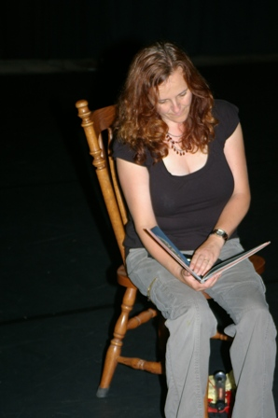
Julie Hartley: A Biography

I was born in a steeltown in the North of England, and started writing my first novel - on a manual typewriter - when I was 15. These days, I live in Toronto with my husband and our daughter, who was adopted from China as a baby. While The Finding Place is entirely fictional, our knowledge of international adoption has certainly influenced the writing of the book.
This is my first published novel, although I have been writing all my life. My poetry and short stories have been published in literary magazines and newspapers in Canada and in England, where I was the recipient of the Peace Poetry Prize and a runner-up for the Pilot Pen Award. I've written numerous plays for young people, many of which have toured in Canada, England and Ireland.
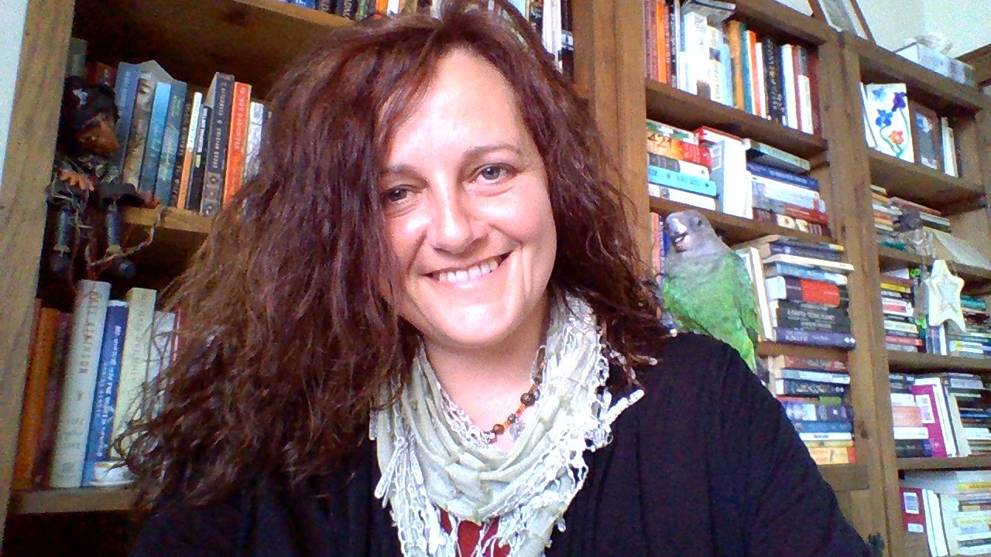
In my non-writing, non-parenting life I am an owner-director of Centauri Summer Arts Camp, which brings together teens from all over the world each summer to work with arts professionals in a residential setting. I have taught drama and creative writing in schools, colleges, universities and for conferences all over the world. Teaching, writing, creating communities for artistic youth – this is the work that drives and inspires me.
Oh – and I love birds. This certainly influenced character creation in The Finding Place. I grew up owning an aviary of tropical finches and these days my feisty parrot chatters on my shoulder while I write.
To find out more about Julie visit her website at www.juliehartley.ca or her twitter feed or her blog at www.juliehartley.ca/blog.

About The Finding Place

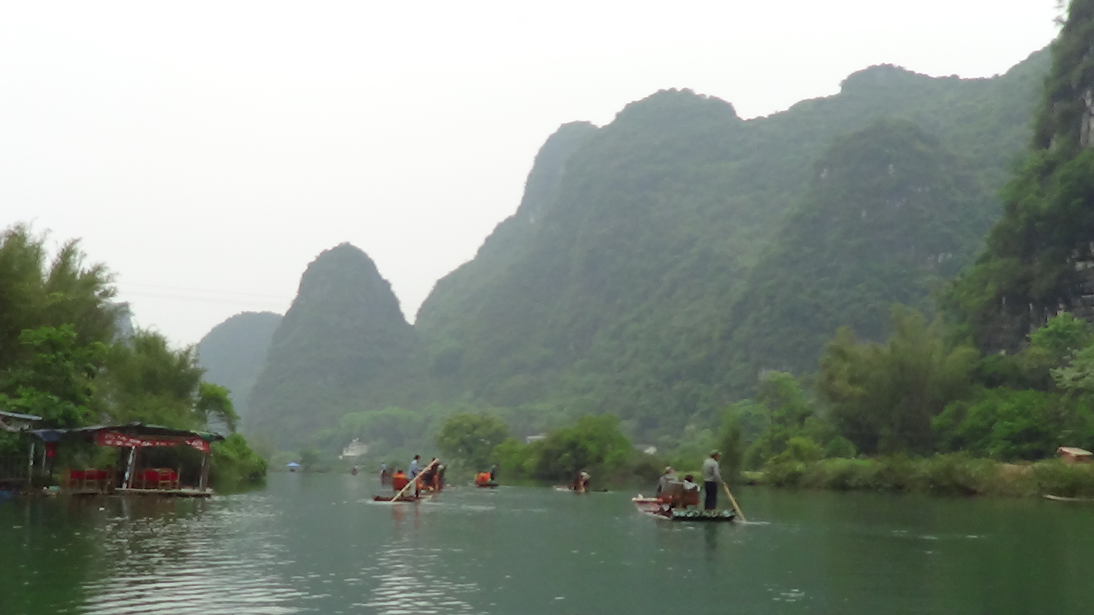
One day, many years ago, my daughter commented that she never got to see herself represented in the fiction she read, and I realised that beyond picture books, there were few books for children that presented the unique growing up struggles of internationally adopted youth. I wanted to write something that would fill that void. The Finding Place was written quickly, in a little village in Mexico that had recently been hit by a tsunami. I wrote the novel mostly on the beach, sitting between giant slabs of concrete that had once been beachfront cafes. The first draft was easy and hugely rewarding, then the novel evolved into something readable over the three years that followed.

Key to the writing of The Finding Place was a research trip to China in which we stayed at an Inn just like the one in the book, walked the pathway along the edge of the Li River, took a trip by bamboo boat and watched cormorant fishing. While Kelly's birth village is entirely fictional, I based my descriptions on a number of villages we visited in the area.

Specifications

- Paperback: 244 pages
- Publisher: Red Deer Press
- Language: English
- ISBN-10: 0889955336
- ISBN-13: 978-0889955332
- Product Dimensions: 13.3 x 2.5 x 19 cm

The following article will be published by an online adoption magazine and provides further information about the book:

Finding The Finding Place
by Julie Hartley

On the day the families in our travel group first met our daughters, the tour guide said: “You are parents now. Forever. If you leave your daughter, she will be abandoned for the second time.” Her normally-smiling face was grave. This was something she needed us to understand. And of course, we did.

But her words stayed with me after we left Guangdong, China, and began our life as a family in Canada. Most children experience loss over the course of a childhood. Take a thousand adoptive parents and statistically, some are going to become seriously ill. Perhaps die. Others will divorce. Children lose grandparents. They experience loss when pets die and best friends move on. And for every loss our girls experienced, there would be a deeper impact. Because none of them would be losing someone close to them for the first time.

I was reading to our daughter at bedtime years later, when she said, “How come no one in these stories looks like me?” I pointed out that in Grace Lin's books the main characters were ethnically Asian. Our daughter said nothing, but I knew what she was thinking. Those kids had parents who looked like them. The stories were about how they experienced a mix of Asian and Canadian culture. Our daughter feels entirely Canadian, but does not look like the entirely-Canadian protagonists in the books she likes to read. She does not look like her parents, nor share their ethnic heritage.

I've always been a writer, and after this moment, I started to think about how I might do something to fill this gap. I wanted to write a novel in which the main character was a Chinese-adopted girl, seeing the world the way our girls do. I thought back to our tour guide's grave words of warning, and the plot for The Finding Place emerged.

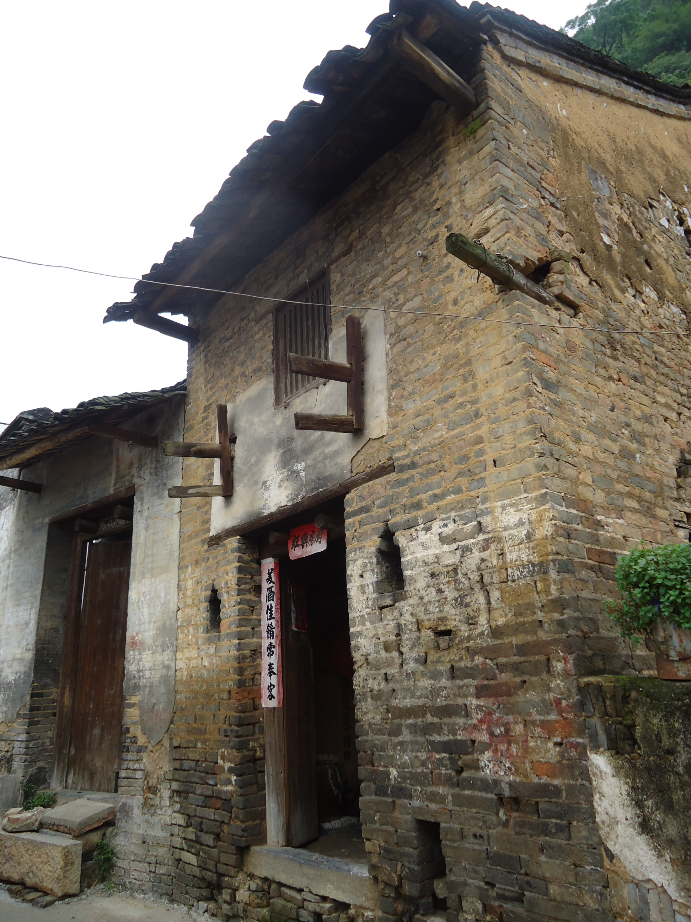
In 2012, we returned to China with our daughter, now 7 years old. We didn't return to Guangdong. Instead, we decided to focus on celebrating our her birth culture. We wanted to give her a sense of curiosity and pride in the place where her life had begun. For that we chose Yangshuo, with its bizarre, pointy mountains and meandering rivers. We explored tiny villages. Climbed Moon Hill. Travelled by bamboo raft. Watching our daughter's eyes shine with wonder, I thought: how would a child feel, if she discovered she was born right here?
The main character of The Finding Place is Kelly, a 13-year-old fictional adoptee whose Chinese heritage becomes of sudden interest after her forever-family disintegrates. Her father is missing. No one will say where he is. And her mother is keeping secrets, shutting Kelly out. Mom hopes a trip back to China might do something to help the rebellious teen 'settle down', but for a while, the reverse happens. Kelly discovers, by accident, the extent of her mom's deception and in a fit of rage, heads off alone through Yangshuo to discover the world she left behind as an infant. It is only when her mom faces danger and Kelly must step in to help that she discovers the true meaning of family.

The Finding Place was picked up by a publisher almost immediately and released across Canada in mid September. It is possibly the first novel published in Canada in the last decade for the 9-14 age range with a Chinese-adoptee as the protagonist. But it is not intended as a special interest book. Kelly experiences divorce, discovers parents are imperfect, learns to cope with new responsibilities and emerges from tough experiences with increased self awareness and a pride in herself and her birth culture. The novel is about growing up and learning to accept who you are. I wanted my story to be relevant to all teens and pre-teens, and the life experiences they share. But Kelly's experiences are shaped by the losses she sustained in the first days of her life. As our tour guide said, for our children, no abandonment will ever be their first. And perhaps this is what makes their world view so unique and challenging, as they navigate childhood in a very imperfect world.

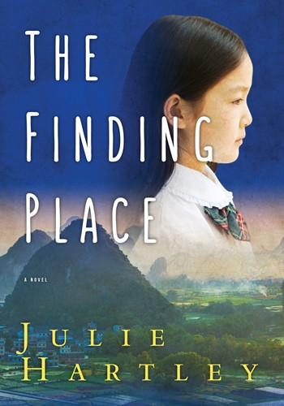
The Finding Place by Julie Hartley was released by Red Deer Press on 15 September 2015.

For interviews and support material such as photographs, you can contact
Red Deer Press directly, or email Julie:
julie@centauriartscamp.com

